 | Mathematics Essential  Test 6, 2015  Topics – Mass, volume & capacity |  | 50  = %
Total Time: | 60 minutes
Total Reading: | 5 minutes
Total Working: | 55 minutes
Weighting: | 4% of the year.
Equipment Allowed: | Calculator, 1 page of A4 notes.
You must include all working out to receive full marks

CALCULATOR ASSUMED
- (3 marks:1, 1, 1)

Which unit, kilogram, milligram, gram, or tonne, would you use to measure each of these masses? You must answer using the correct abbreviations.

- A truck.

b) A grain of rice.

c) An orange.

- (2 marks:1, 1)

Express 750g in:

- Milligrams.

- Kilograms.

- (3 marks:1, 1, 1)

For the objects below, select the most appropriate mass from: 61kg, 14kg, 2kg, 32kg, 190g, and 13g.

- 2L of milk.

- Microwave oven.

- An apple.

- (7 marks:1, 1, 1, 1, 1, 1, 1)

This information is provided on a bottle of Caesar Salad dressing.

NUTRITIONAL INFORMATION #
SERVINGS PER PACK – 12 SERVING SIZE 20mL
 | QUANTITY PER SERVING | QUANTITY PER 100mL
ENERGY | 424 kj | 2120 kj
PROTIEN | 0.3 g | 1.5 g
FAT, TOTAL | 10.7 g | 53.5g
- saturated | 1.1 g | 5.5 g
CARBOHYDRATE | 5.6 g | 28 g
- sugars | 4.2 g | 21g
SODIUM | 300mg | 1500mg

- How many servings are there in the bottle?

- How big is each serving?

- How many mL does the bottle contain?

- How many grams of non-sugar carbohydrates are in one serving?

- In one serving, are there more grams of protein or of sodium?

- According to the nutritional information on the label, what percentage of the carbohydrate in the dressing is sugar?

- Salt is sodium chloride, or sodium. How much salt is in a bottle of this dressing?

- (3 marks:1, 2)

A standard house brick has a mass of 2·7kg.

- A pallet of standard house bricks contains 500 bricks. Calculate the mass of one pallet of normal house bricks. Express your answer in kilograms.

- A truck has a load of 8 pallets of standard house bricks. Calculate the weight of the load in tonnes.

- (2 marks)

Clarks rule for calculating a child’s dose of medicine is based on the child’s weight.

Child dose = (Weight of the child in kilograms ÷ 70) × Adult dose

If the adult dose of medicine is 40mL, what is the child dose for Bob weighing 14kg?

- (3 marks:1, 1, 1)

Which unit, cubic metre, cubic millimetre, or cubic centimetre, would you use to measure each of these volumes? You must answer using the correct abbreviations.

- An EFTPOS card.

b) Your mathematics classroom.

c) The contents of a box of cereal

- (4 marks:1, 1, 1, 1)

Given that the shape below is a 1cm cube.

Determine the volume of each shape below. Write your answers next to each diagram.

- (3 marks:1, 1, 1)

Convert the following:

- 1·68m³ to cm³

- 126mm³ to cm³

- 0·0345m³ to litres

- (3 marks:1, 1, 1)

For the objects below, select the most appropriate volume from: 89cm³, 4m³, 6m³, 1100cm³ , 950cm³, and 13cm³.

- Your mathematics text book.

- 1L carton of milk.

- An apple.

- (9 marks:3, 3, 3)

Calculate the volume of each prism below.
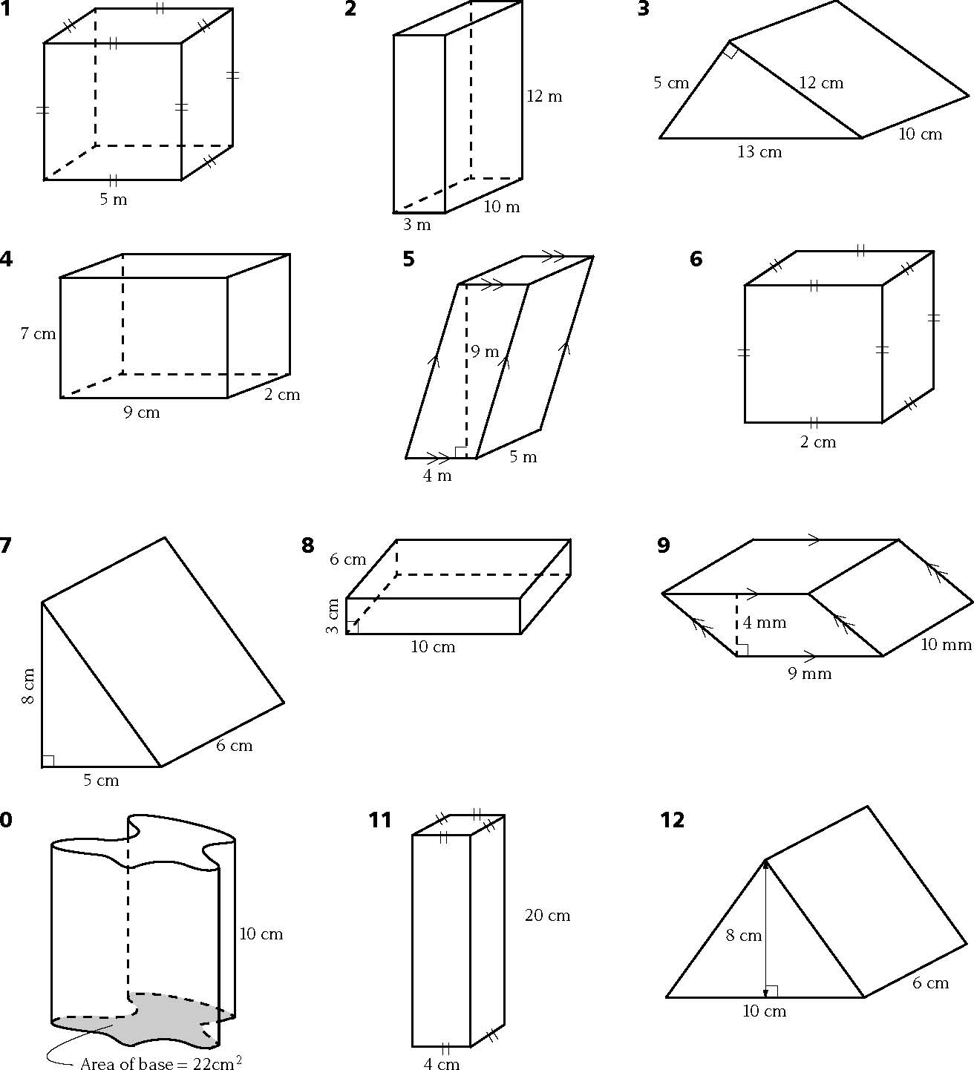
a)

b)
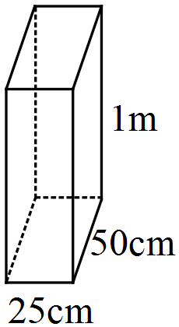

c)
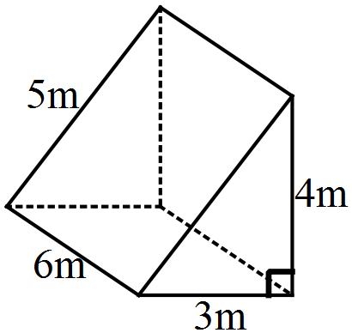
10cm

- (3 marks)

In times of drought some farmers need to purchase drinking water. Farmer Jack needs to buy water weekly and he does so in a tank in the shape of a rectangular prism. The tanks dimensions are 2m by 1·5m by 1m.
Calculate the capacity of the tank.

- (3 marks:2, 1)

A triangular prism is 60cm tall.

- What is the area of the triangular base if the volume of the triangular prism is 360cm³?

- For the triangular base. What could be the length of the base and perpendicular height?

- (2 marks)

A carton of soft drink contains 24 cans. Each can holds 375mL. How many litres are there in the carton?

